**CS590BD Big Data Analytics and Applications**

**Lab 1 Assignment- Task 2 & 3**

**By**

**Vidhi Shah**

Task:2 Cloudera Installation and MapReduce application "Word Count". Write a report on this task.

**Installation of cloudera quickstart vm player:**

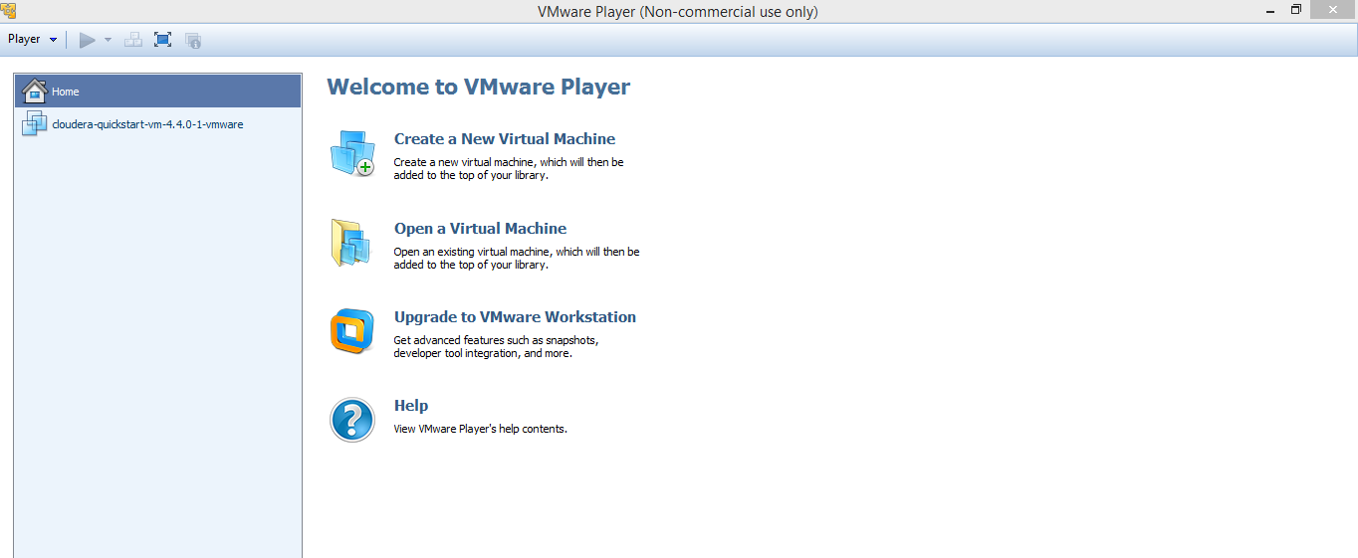

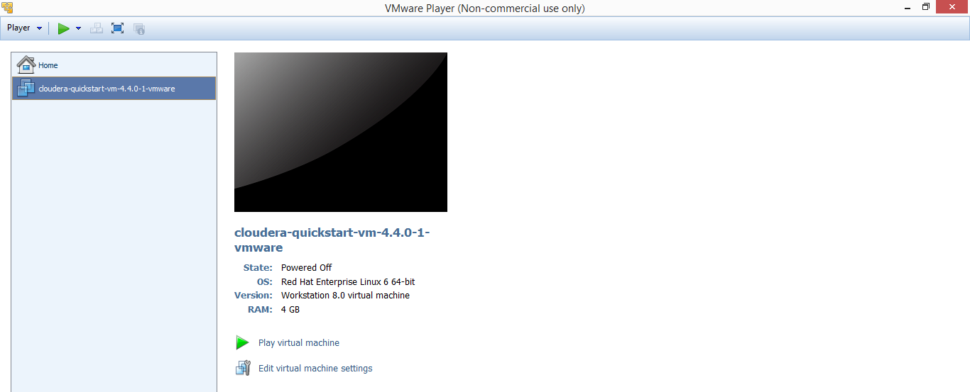

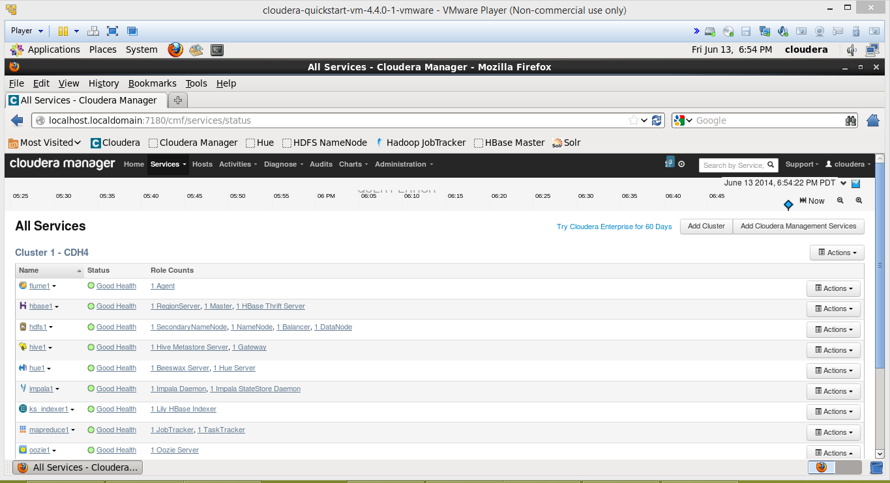

**Word count exercise:**

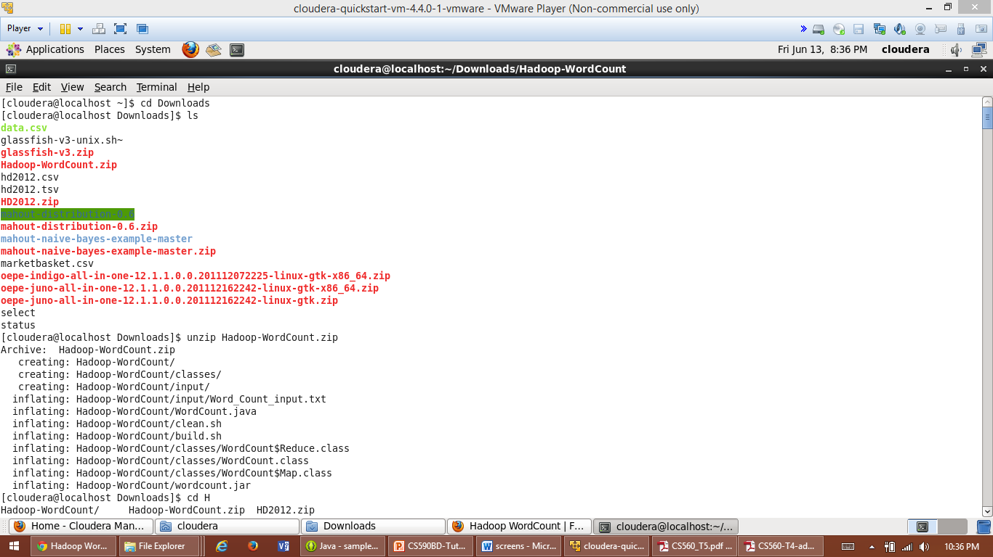

**Command:**

hadoop fs –put input input

hadoop jar wordcount.jar WordCount input output3

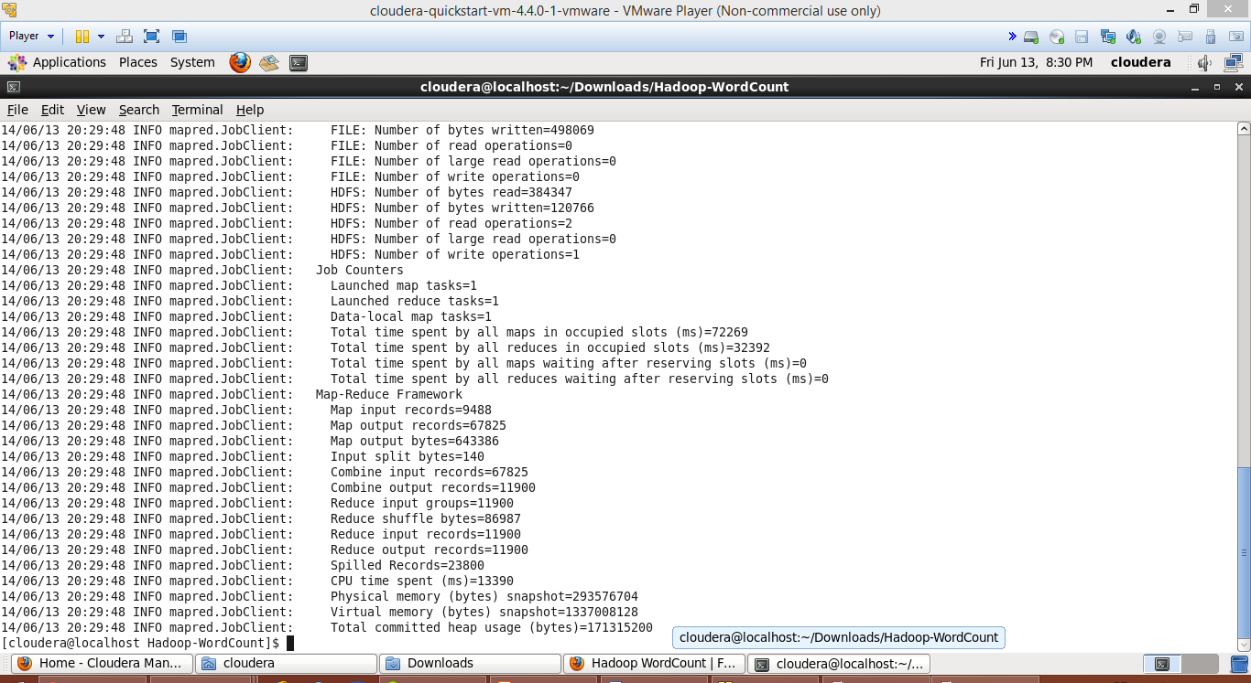

**Command:**

hadoop fs -cat output3/*

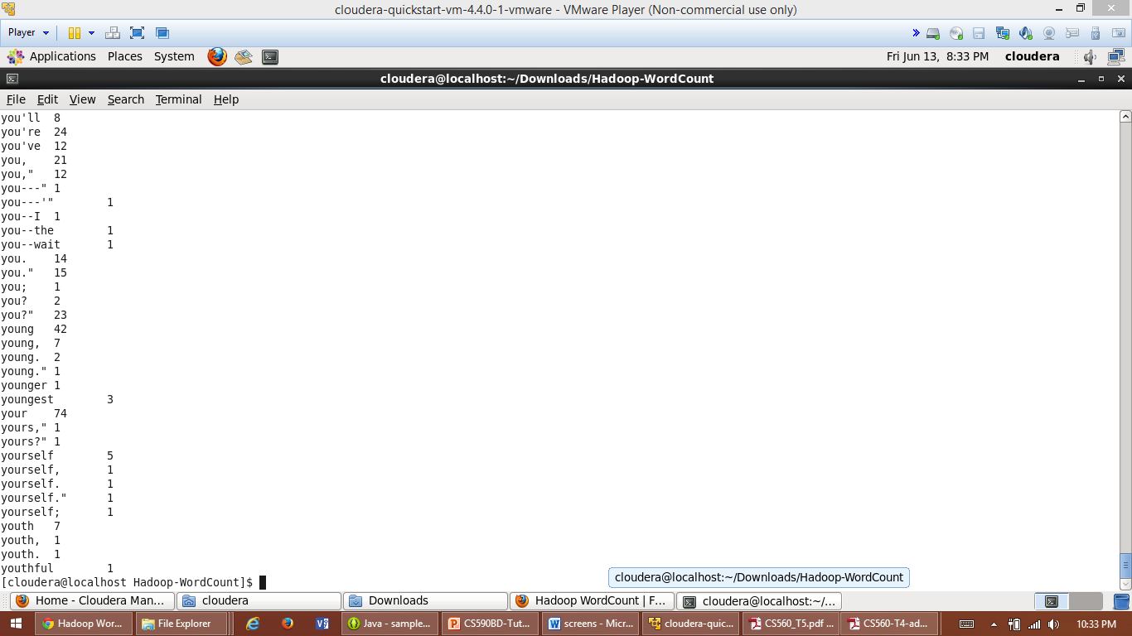

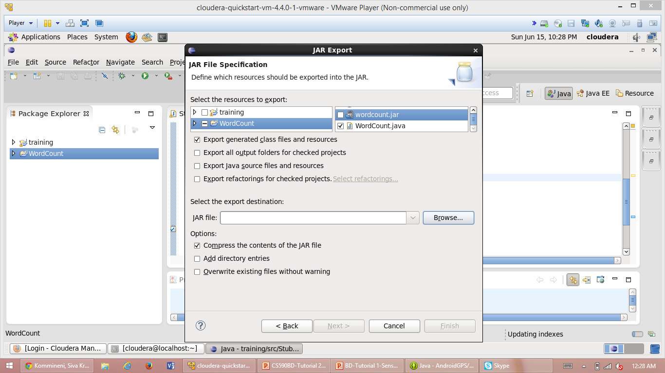

**java based restful service :**

